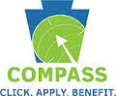 **PUBLIC ASSISTANCE**

**How to apply for Public Assistance**:

1. On line at[**www.compass.state.pa.us**](http://www.compass.state.pa.us)
2. Visit your local County Assistance Office (COA) and fill out the paper application (which is about 15 pages long)

**TYPES OF PUBLIC ASSISTANCE**

1. **Food Stamps/Supplemental Nutrition Assistance Program (SNAP)**

**How Do I Know if I am Eligible?**

As of October 2014:

(in order to qualify all the members of your household cannot make more than…)

|  |  |  |
| --- | --- | --- |
| **Household Size** | **Max Gross Monthly Income** | **Max Gross Monthly Income for households that have an elderly or disabled member** |
| 1 | $1557 | $1946 |
| 2 | $2098 | $2622 |
| 3 | $2640 | $3300 |
| 4 | $3181 | $3976 |
| 5 | $3722 | $4652 |
| 6 | $4264 | $5330 |
| 7 | $4805 | $6006 |
| 8 | $5346 | $6682 |
| 9 | $5888 | $7360 |
| 10 | $6430 | $8038 |
| each additional member | +$542 | +$678 |

*But if you are unsure you can just apply anyways to see if you qualify….*

**How Do I Apply?**

* 1. 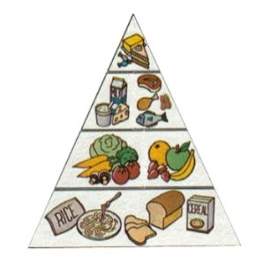You can apply for or renew your SNAP benefits by using COMPASS. Or you can file an application at your local COA. (if you have any problems with food stamps you can contact Just Harvest at 412-431-8960 or [www.justharvest.org](http://www.justharvest.org))
  2. The following persons may apply for benefits for the household:
* The head of the household;
* The spouse of the head of household;
* Any other responsible household member; or
* A designated authorized representative, who can be a friend, relative, neighbor, or anyone else the applicant trusts to go food shopping and use his/her SNAP benefits.
  1. You will have a face-to-face office interview after you fill out and submit the application.
     + You will have to bring a lot of things to your interview like proof of identity, social security cards of everyone in the home, proof of residence, birth certificates of everyone in the home, proof of income, proof of shelter costs (i.e. rent, utility bills)
  2. You receive an ACCESS Card within a month of applying and being approved for SNAP
     + ****You select a personal identification number (PIN) to access authorized benefits. The Access Card is used for payment. You can swipe the card and enter the PIN to access the funds in the SNAP account. Your account is then debited for the amount of the purchase.

**What Can I Buy?**

1. SNAP benefits may be used to buy the following:
   * + Food for human consumption, including soft drinks, candy, ice cream, and coffee
     + Seeds and plants to grow food for personal consumption
2. What SNAP does not cover:
   * + 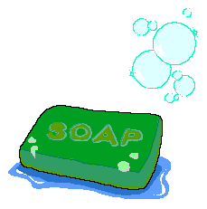Alcohol, pet foods, hot foods, or hot food products prepared for immediate consumption (such as fried chicken)
     + Some energy bars (Balance, ZONE, & LUNA Bars) and energy/protein drinks
     + 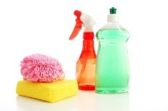Non-food items, such as paper products, soap, household supplies, medicines, and tobacco products
3. **Medical Assistance**
   1. Medical Assistance(MA) pays for health care services for eligible individuals
   2. ****The Pennsylvania Health Law Project has an Eligibility Screening for MA on their website <http://www.phlp.org/quickscreen-questionnaire>
4. **Children’s Health Insurance Program (CHIP)**

**What Is It?**

Offers comprehensive health insurance coverage for routine doctor visits, prescriptions, dental, eye care and much more, including:

•Immunizations

•Routine Check-ups & Well Visits

•Prescription Drugs

•Dental, Vision, Hearing

•Emergency Care

•Mental Health Benefits  
•Hospitalization  
•Durable Medical Equipment

•Substance Abuse Treatment

•Partial Hospitalization for mental health

•Rehabilitation Therapies

•Home Health Care  
•Maternity Care  
•Hospice & Palliative Services  
 •Medically Necessary Orthodontia  
•Autism Spectrum Disorder & Related Services

**How Do I Know If I am Eligible?**

* Check out the income guidelines chart on [www.chipcoverspakids.com](http://www.chipcoverspakids.com)
* Covers all kids in PA under age 19 who are not eligible for medical assistance
* No family makes too much money for CHIP. Many will get if free, others at low cost

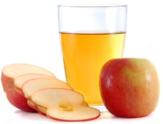****

1. **Women Infants and Children (WIC)**

**What is WIC?**

* + 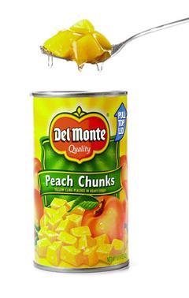Provides milk, juice, formula, fresh fruit and vegetables, canned fruit, canned/frozen vegetables and other items to low-income pregnant or breastfeeding women, as well as infants and children up to age 5
  + The average value of food each month is $50.

**How Do I Get It?**

* + Must meet income guidelines, call 412-350-5801 <http://www.achd.net/wic/>

1. **Housing Assistance**
   1. Public Housing, which provides affordable apartments for eligible low-income families, the elderly and persons with disabilities
      * Properties owned and managed by the city of Pittsburgh:
        1. Addison Terrace—Hill District
        2. Allegheny Dwellings—North Side
        3. Arlington Heights—South Side
        4. Bedford Dwellings—Hill District
        5. Glen Hazel—Hazelwood
        6. Homewood North—Homewood
        7. Northview Heights—North side
      * Properties that are privately managed in the city of Pittsburgh:
        1. Garfield Commons
        2. Bedford Hill—Hill District
        3. Oak Hill—Hill District
        4. Manchester—North Side
        5. New Pennley Place—East Liberty
      * McKeesport Housing Authority:
        1. Crawford Village; 2. Harrison Village; 3. Locust Street
      * Housing Authority of Allegheny County
   2. Housing Choice Voucher Program (Section 8), which provides vouchers to eligible low-income and working families to pay for all or part of the rent
   3. Homeless Assistance Program (HAP) provides rental assistance, case management, emergency shelter, bridge housing and innovative support housing services
   4. Emergency Shelter Allowance (ESA) helps a homeless or near homeless family/individual to:
      * Stop eviction from your home/apartment or foreclosure of your house
      * Find a long-term place to live or find a short-term place to stay
      * To be eligible for an ESA, you also must meet all income, resource, and non-financial guidelines. The ESA payment amount, up to $400, depends on your needs, situation, and emergency.
      * Apply at the county assistance office and provide proof of the emergency and the amount needed to stop the emergency and proof that an ESA will solve your housing crisis
2. **Cash Assistance**

**What is it?**

AKA: Temporary Assistance for Needy Families (TANF) provides money to help:

* Pregnant women
* Dependent children and their parents who live with them
* Dependent children & other relatives who live with them & care for them
* **You can only get TANF for 5 years in total**. It does not need to be consecutive to count towards the 5 year limit.
* Your resources (things with cash value such as bank accounts, bonds or property that is not your primary/main residence) must have a value of $1,000 or less.
* *If you receive TANF you will have to participate in* ***mandatory work requirements*** *or be in an* ***active job search or education/training leading to employment****.*

1. **Child Care**
   1. 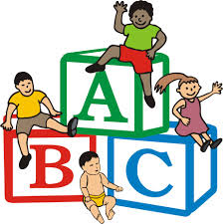Child Care Works Program offers child care subsidies to low-income families
      * You must work 20 hrs or more a week **OR**
      * Work 10 hrs and go to school or train for 10 hrs a week **OR**
      * Have a promise of a job that will start within 30 days of your application for subsidized childcare
   2. Contact Child Care Information Services (CCIS) 412-261-2273 or Child Care Works Helpline 1-877-4PA-KIDS (1-877-472-5437)

**Specialized Programs:**

|  |  |
| --- | --- |
| **Jeremiah’s Place:**   * + - Located in the Kingsley Center on Frankstown Ave in Homewood     - Open 24/7 to all children ages 6 and under for free, temporary short-term care when families are in crisis or an experiencing emergency situation and need safe care for their children. The crisis may be emergency medical care, urgency childcare needs, and care of children at risk for child abuse | **Angels’ Place:**   * + - Locations in the North Side, Brookline and Swissvale     - Provide free childcare to low income single parents who are full time students and whose children are under the age of 5. |

1. **Free or Reduced Cost School Meals**
2. **Employment Placement Services**
3. **Earned Income Tax Credit:** If you work and have a qualifying child, you may be eligible to receive earned income tax credit. To claim the credit you must file a federal tax return. If you pay state income taxes, PA may owe you a refund under PA Tax Forgiveness, call PA Dept of Revenue at 717-787-8201 or visit [www.revenue.state.pa.us](http://www.revenue.state.pa.us)